Name: Krithika shree.K
Reg No: 24MIS0015

17-09-26 agile lab

PROJECT 1: Parameterized Build Pipeline
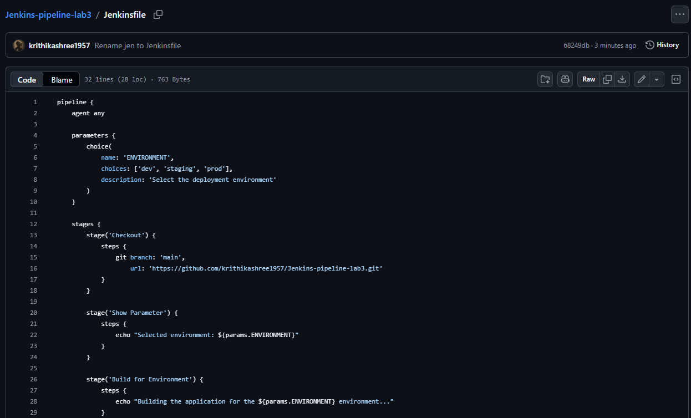

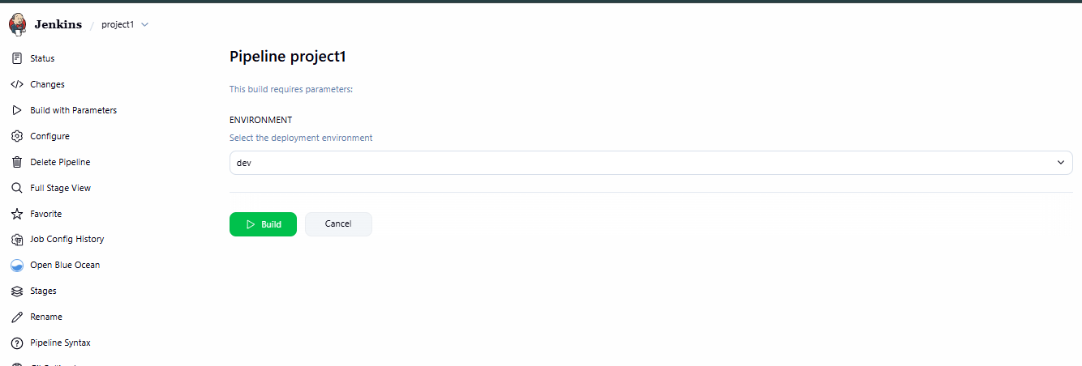

Parameter: dev
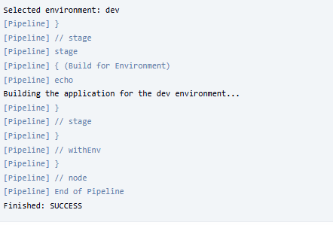

Parameter: Staging
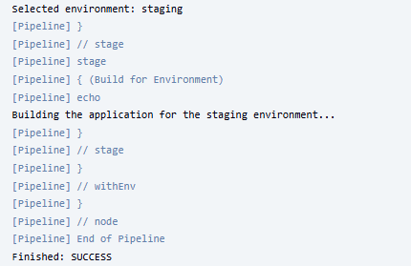

Parameter: prod
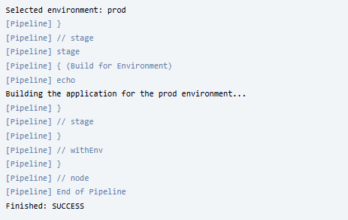

PROJECT 2: Archive Build Artifacts Pipeline
pipeline script:
pipeline {
agent any
stages {
stage('Checkout') {
steps {
checkout scmGit(branches: [[name: '**']], extensions: [], userRemoteConfigs: [[url: 'https://github.com/krithikashree1957/Jenkins-pipeline-lab3.git']])
}
}
stage('Generate Report') {
steps {
bat 'python app.py'
}
}
stage('Archive Report') {
steps {
archiveArtifacts artifacts: 'report.txt', followSymlinks: false
}
}
}
}
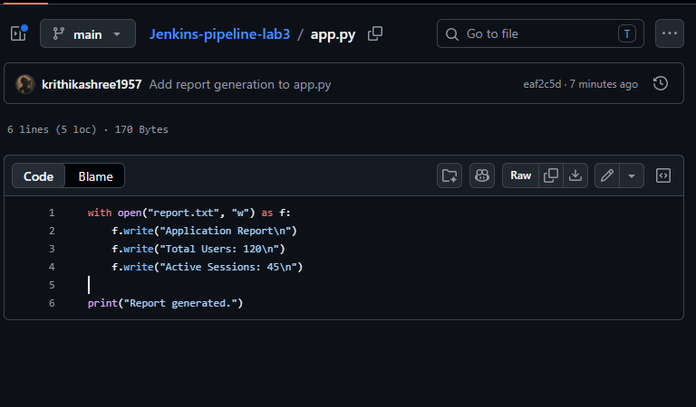

Archive Report:
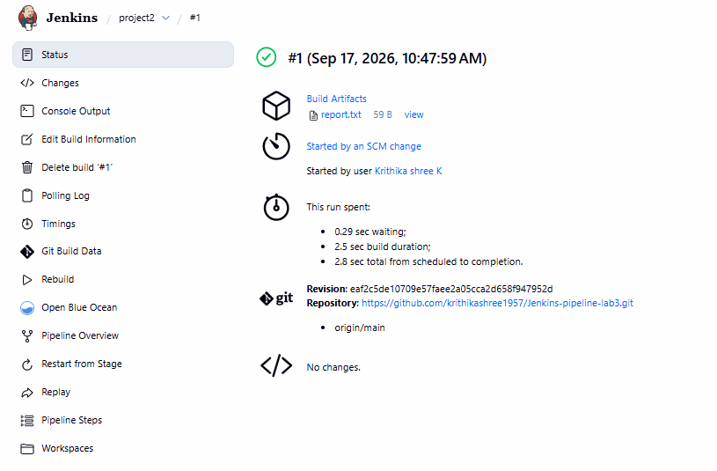

report.txt content:

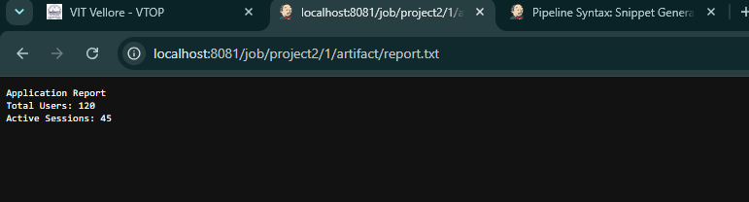
after changing total user to 200
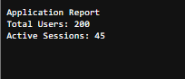

PROJECT 3: Parallel Stages Pipeline
pipeline script:
pipeline {
agent any

stages {
stage('Checkout') {
steps {
git branch: 'main',
url: 'https://github.com/krithikashree1957/Jenkins-pipeline-lab3.git'
}
}

stage('Parallel Checks') {
parallel {
stage('Frontend Check') {
steps {
bat 'python frontend_check.py'
}
}

stage('Backend Check') {
steps {
bat 'python backend_check.py'
}
}
}
}

stage('Summary') {
steps {
echo 'Both frontend and backend checks are complete.'
}
}
}
}

files in github:
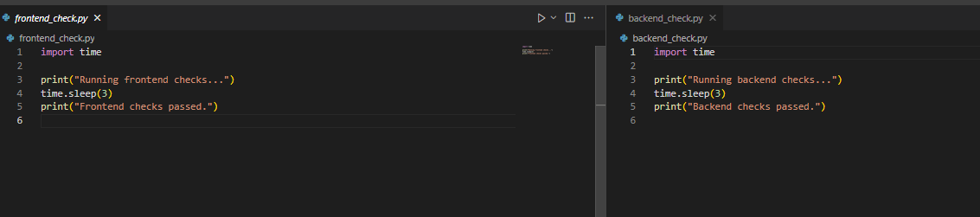
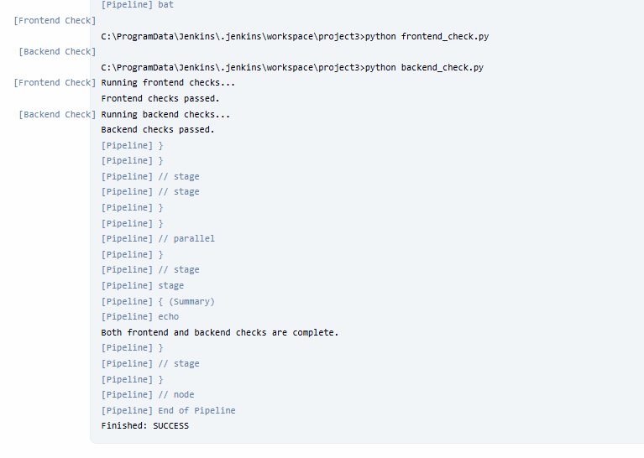
console output:

PROJECT 4: Conditional Stage Execution Pipeline
pipeline script:

pipeline {
agent any

parameters {
booleanParam(
name: 'RUN_EXTRA_CHECK',
defaultValue: true,
description: 'Run the extra check stage'
)
}

stages {
stage('Checkout') {
steps {
checkout scmGit(branches: [[name: '**']], extensions: [], userRemoteConfigs: [[url: 'https://github.com/krithikashree1957/Jenkins-pipeline-lab3.git']])
}
}

stage('Build') {
steps {
bat 'python -m py_compile app_project4.py'
echo 'Build successful: app_project4.py compiled with no syntax errors'
}
}

stage('Extra Check') {
when {
expression {
params.RUN_EXTRA_CHECK == true
}
}

steps {
echo 'Running extra check: verifying greet() output format...'
bat 'python -c "from app_project4 import greet; print(greet(\'Student\'))"'
}
}
}
}

initial build:
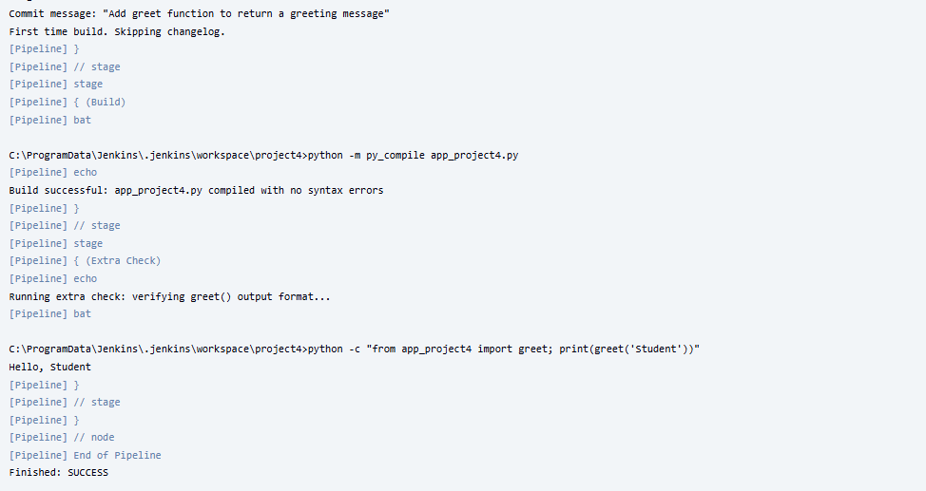
build with parameter:(unchecking RUN_EXTRA_CHECK)

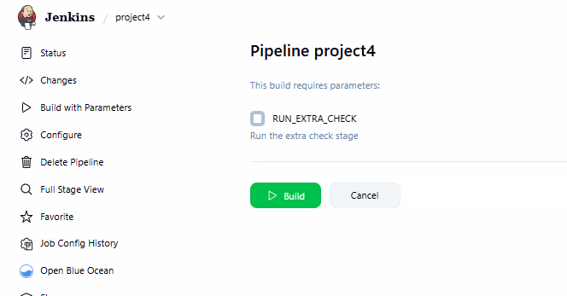

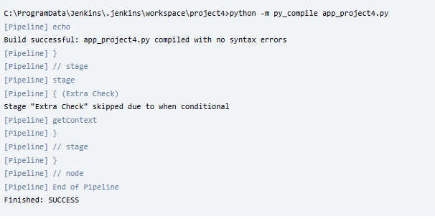
EXTRA CHECK SKIPPED:

PROJECT 5: Custom Environment Variables Pipeline
pipeline script:
pipeline {
agent any
environment {
APP_NAME = 'GradeBookApp'
APP_VERSION = '1.0.0'
}
stages {
stage('Checkout') {
steps {
checkout scmGit(branches: [[name: '**']], extensions: [], userRemoteConfigs: [[url: 'https://github.com/krithikashree1957/Jenkins-pipeline-lab3.git']])
}
}
stage('Show App Info') {
steps {
echo "Building ${env.APP_NAME}, version ${env.APP_VERSION}"
}
}
stage('Build') {
steps {
bat 'python -m py_compile app_project5.py'
echo "${env.APP_NAME} version ${env.APP_VERSION} compiled successfully."
}
}
}
}
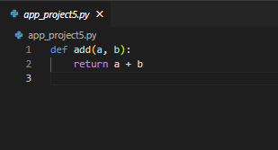

Console output:
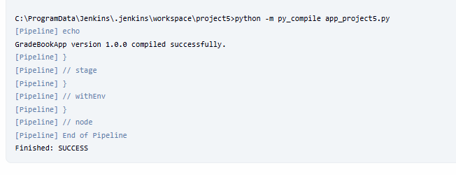
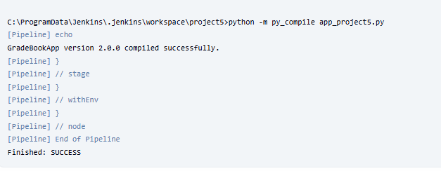
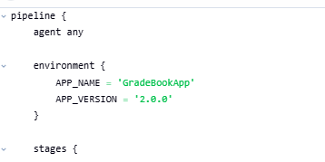
changing APP_VERSION = '2.0.0' in pipeline script:

